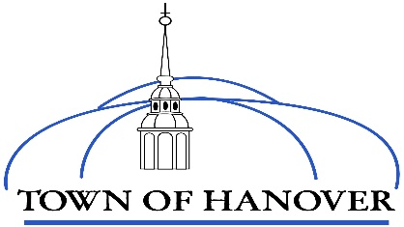
July 25, 2025

Dear Hanover Property Owners,

The Assessing Department has completed a statistical revaluation update for tax year 2025. You will be receiving your new value shortly. The valuation update was completed in-house by staff certified by the State of NH - Office of Professional Licensing.

As you are aware the housing market has been in a constant state of increasing value, which is not isolated to Hanover. The last town wide revaluation was in 2021 and since then, values have appreciated, and the 2024 sales to assessment ratio is 70%. This means that on average, assessments have been 70% of recent sales prices. To bring our overall assessments to 100%, which is mandated by NH State Standards, the assessments have increased on average 44%. The math is .70 times 1.44 = 1.00, not .70 times 1.30.

If your assessment goes up higher than 44% then you are likely to see a tax increase in your fall tax bill. If it goes up less than 44% you would see a decrease in your fall tax bill. Different property types will go up or down and different rates. Properties that were not as desirable become more sought after and increase at higher rates than other properties.

An area where there is generally little change in value is the downtown commercial properties which operate based on investor motive. They are driven by rental rates and borrowing costs, which have changed little, if any. These types of properties tend to end up with reduced taxes.

We will allot time for taxpayers to question their assessments in August after new value notices are mailed. Property owners will have ample opportunity to meet with department staff to discuss their new assessment. This can be done in-person, via zoom or a telephone call. There is an on-line scheduling tool for your convenience which can be found prominently displayed on the Hanover Assessing Department webpage. Additionally, all instructions on how to reach us will be in the notice of the new assessment letter. All analysis reports including old to new assessments will be posted on The Hanover Assessing Department Revaluation Page. The Hanover Assessing Department is committed to completing this revaluation in a professional manner following the State of New Hampshire assessing standards.

I expect to wrap up the informal meetings at the end of August and the required state filing will be made to establish a tax rate soon after so that tax bills can be mailed in a timely manner. I encourage you to visit the Town of Hanover Assessing Department webpage www.hanovernh.org under the GIS tab or refer to the Assessing department to and review townwide assessments.

Best Regards,
Norm Bernaiche
Norm Bernaiche, CNHA
Director of Assessing
603-640-3206 (Direct)

