EPA Researchers are partnering with the Town of Hanover to Evaluate the Impact of Brass Service Lines to Lead in Drinking Water

EPA researchers, through our contractor, Verina Consulting Group LLC (VERINA), will be contacting you to provide more details about the study, answer any questions, and formally invite you to participate. If you choose to participate, they will then set up an appointment for drinking water sampling at your home. You will need to be home during the appointment. We recognize you are busy and will schedule appointments at times that are convenient for you.

Prior to the first appointment, you may need to stagnate – or not run your water anywhere in your home – for several hours during the workday or overnight.
During the appointment, the researchers will take a variety of water samples from your kitchen faucet. These water samples will tell the researchers if there is any lead in your drinking water, and where the sources are located. Extensive sampling like in this study can often cost residents a lot of money, but EPA is working with the Town of Hanover and NHDES to offer this resource for free.

Sampling Methods Used in this Study

Initial Sampling Appointment

During the first sampling appointment, you can expect the contractors to be in your home for approximately 60 minutes. They may need to see where the service lines enter your home, but most of the time will be in your kitchen working with the water from the tap. You can expect the following sampling approaches to take place during that first visit.

1. First Draw Sampling – after stagnating, or not running water, for a prolonged period of time, two small samples and one medium sample will be collected. This means that the water in your home cannot be used for any reason - including flushing toilets or washing your hands - prior to our team collecting the sample. We know this is an inconvenience to you. Due to this requirement, early morning or after the workday is the best time to collect samples. Our team will work with you to be as flexible as possible to accommodate your schedule.
2. Sequential Sampling – these samples will be collected right after the first draw. The samples will include 13 to 16 quart-sized bottles collected to represent locations throughout the plumbing in your home. As you can see from the figure below, these samples represent the kitchen faucet all the way to the water main to identify any location of lead contamination in the plumbing line.

3. Flushed Sampling – after the sequential sampling is completed, water has been running in your home long enough where none of the water collected at this point will have been stagnant in the service line or premise plumbing. A single sample will be collected at full flow, approximately 1.5 gallons per minute, to indicate if there are very high lead concentrations.
4. Manual Composite Sampling – These are samples that represent a mixture of individual samples (grab samples) collected over a specific period of time, for example 24 hours for a daily composite. The contractor will leave a bottle with you that you will fill gradually throughout your day as you use water in your home for drinking or food preparation, and then come collect the bottle at a very brief follow up appointment.
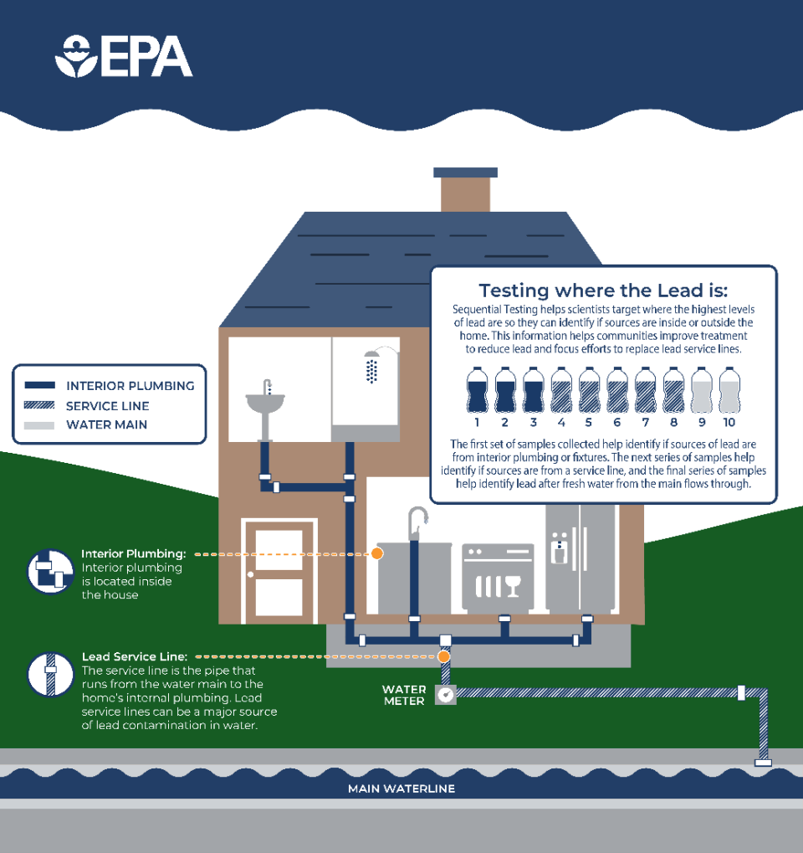
Figure 1-Schematic of sequential sampling research.

Follow Up Appointment

The follow up appointment will be brief, requiring only a few minutes of your time, and will take place within a week of the initial appointment. There are no water use restrictions prior to the sampling, so this appointment can be any time during the day. At this time, EPA’s contractor will collect the Manual Composite Sample that you have filled over time from your tap.
5. Random Daytime Sampling – They will also take one additional sample from your tap, known as a Random Daytime Sample. This is a sample that is taken at a random time of day directly from the tap in a property without previous flushing.

VERINA Environmental Contractors

These water samples will be collected by experienced EPA contractors. The contractors will coordinate with you prior to the sampling appointments, show you their ID during the sampling appointments and respect your home while there.
With your permission, a photograph may be taken of your kitchen faucet and the location where your water service line enters your home. The contractor will place a unique sampling location identification number (ID), date, and the sampling staff names on a sheet of paper or white board for identification of any photographs.

Background

Lead is one of the most challenging pollutants affecting our drinking water. While the Town of Hanover Water Utility provides drinking water that continues to meet federal and state drinking water quality standards, including standards for lead in drinking water, the Water Utility, and researchers from the EPA would like your help in evaluating whether brass service lines or galvanized iron contribute any lead to drinking water.
Lead can enter drinking water from a variety of plumbing materials installed prior to its ban. The most common sources of lead in drinking water are old lead service lines, lead-containing faucets, other lead-containing plumbing fixtures, leaded brasses, leaded solder joints, and galvanized iron downstream of a lead source (A service line is the pipe that connects the water main at the street to the plumbing in a home or building).

The risk of lead contamination with lead service lines is well understood, but information on other potential sources to lead in drinking water such as brass or galvanized service lines is needed because these sources may still be present in water systems after lead service lines are removed. The study you will be part of will help refine water sampling approaches by identifying sources of lead in your home and will also give the (city name) Water Utility more tools to know how water lead levels are impacted by brass/galvanized service lines.

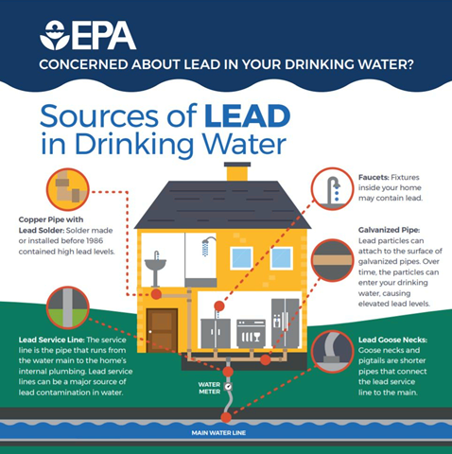
Figure 2-Possible sources of lead in drinking water.

