Food Truck Guidelines
The following will serve as a guideline for food trucks / trailers (both generally referenced as “food truck” going forward in this document) operating in the Town of Hanover.
Permit Requirements:
- A Mobile Food Unit License is required by the State of New Hampshire and can be obtained from the Department of Health and Human Services.
- A Mobile Food Truck permit is required annually from the Planning and Zoning Department along with a public health inspection.
Parking Requirements:
- Both the state Mobile Food Unit License and Town Mobile Food Truck permit are required before a food truck space can be reserved with Hanover Parking. Copies of both permits must be submitted annually along with a Food Truck Parking Permit Application and a current picture of the vehicle and will be kept on file by the Parking Division.
- A total of 8 Food Truck Spaces have been identified in the Town of Hanover at this time (see reverse side for map and description of locations). Operating a food truck at any other location within the Town is not permitted.
- Reserving a Food Truck Space will be at the rate of $50.00 per day for the two parking spaces designated as a Food Truck Space regardless of the size of the food truck. Reservations shall be made by noon the day before the space is requested, or by noon on Friday for any reservations requested for Saturday, Sunday, or Monday.
Reservations can be made via email (parking@hanovernh.org), phone at 603-640-3220, or in person at Town Hall only.
- A food truck and all accompanying equipment (to include but not limited to generators, tables, advertising signs, etc.) must fit within the two designated parking spaces. Equipment cannot be placed outside of the painted parking lines for these two spaces or on the adjacent sidewalk.
- If a trailer is used, it must always remain attached to the tow vehicle, and both vehicles must fit within the two designated parking spaces.
- Food trucks must park with the flow of traffic and be equipped to vend from the sidewalk side of the vehicle.
- If a reservation for a Food Truck Space is not canceled by 9:00am Monday – Friday, or by 4:30pm on Friday afternoon for a Saturday/Sunday reservation, then the entity who made the reservation will be responsible for the $50.00 fee for the day.
- If payment for any reservations from the prior week has not been received by 9:00am on the following Monday morning, any future reservations will be canceled until payment in full has been made. Payments can be made in person or via phone during normal business hours (8:30am- 4:30pm Monday through Friday, holidays excluded) or via the internet 24/7 at https://parking.hanovernh.org/.
- These guidelines may be reviewed and changed without prior notice. Any changes will be communicated to those with an existing Food Truck Permit.
Food Truck Zone 1
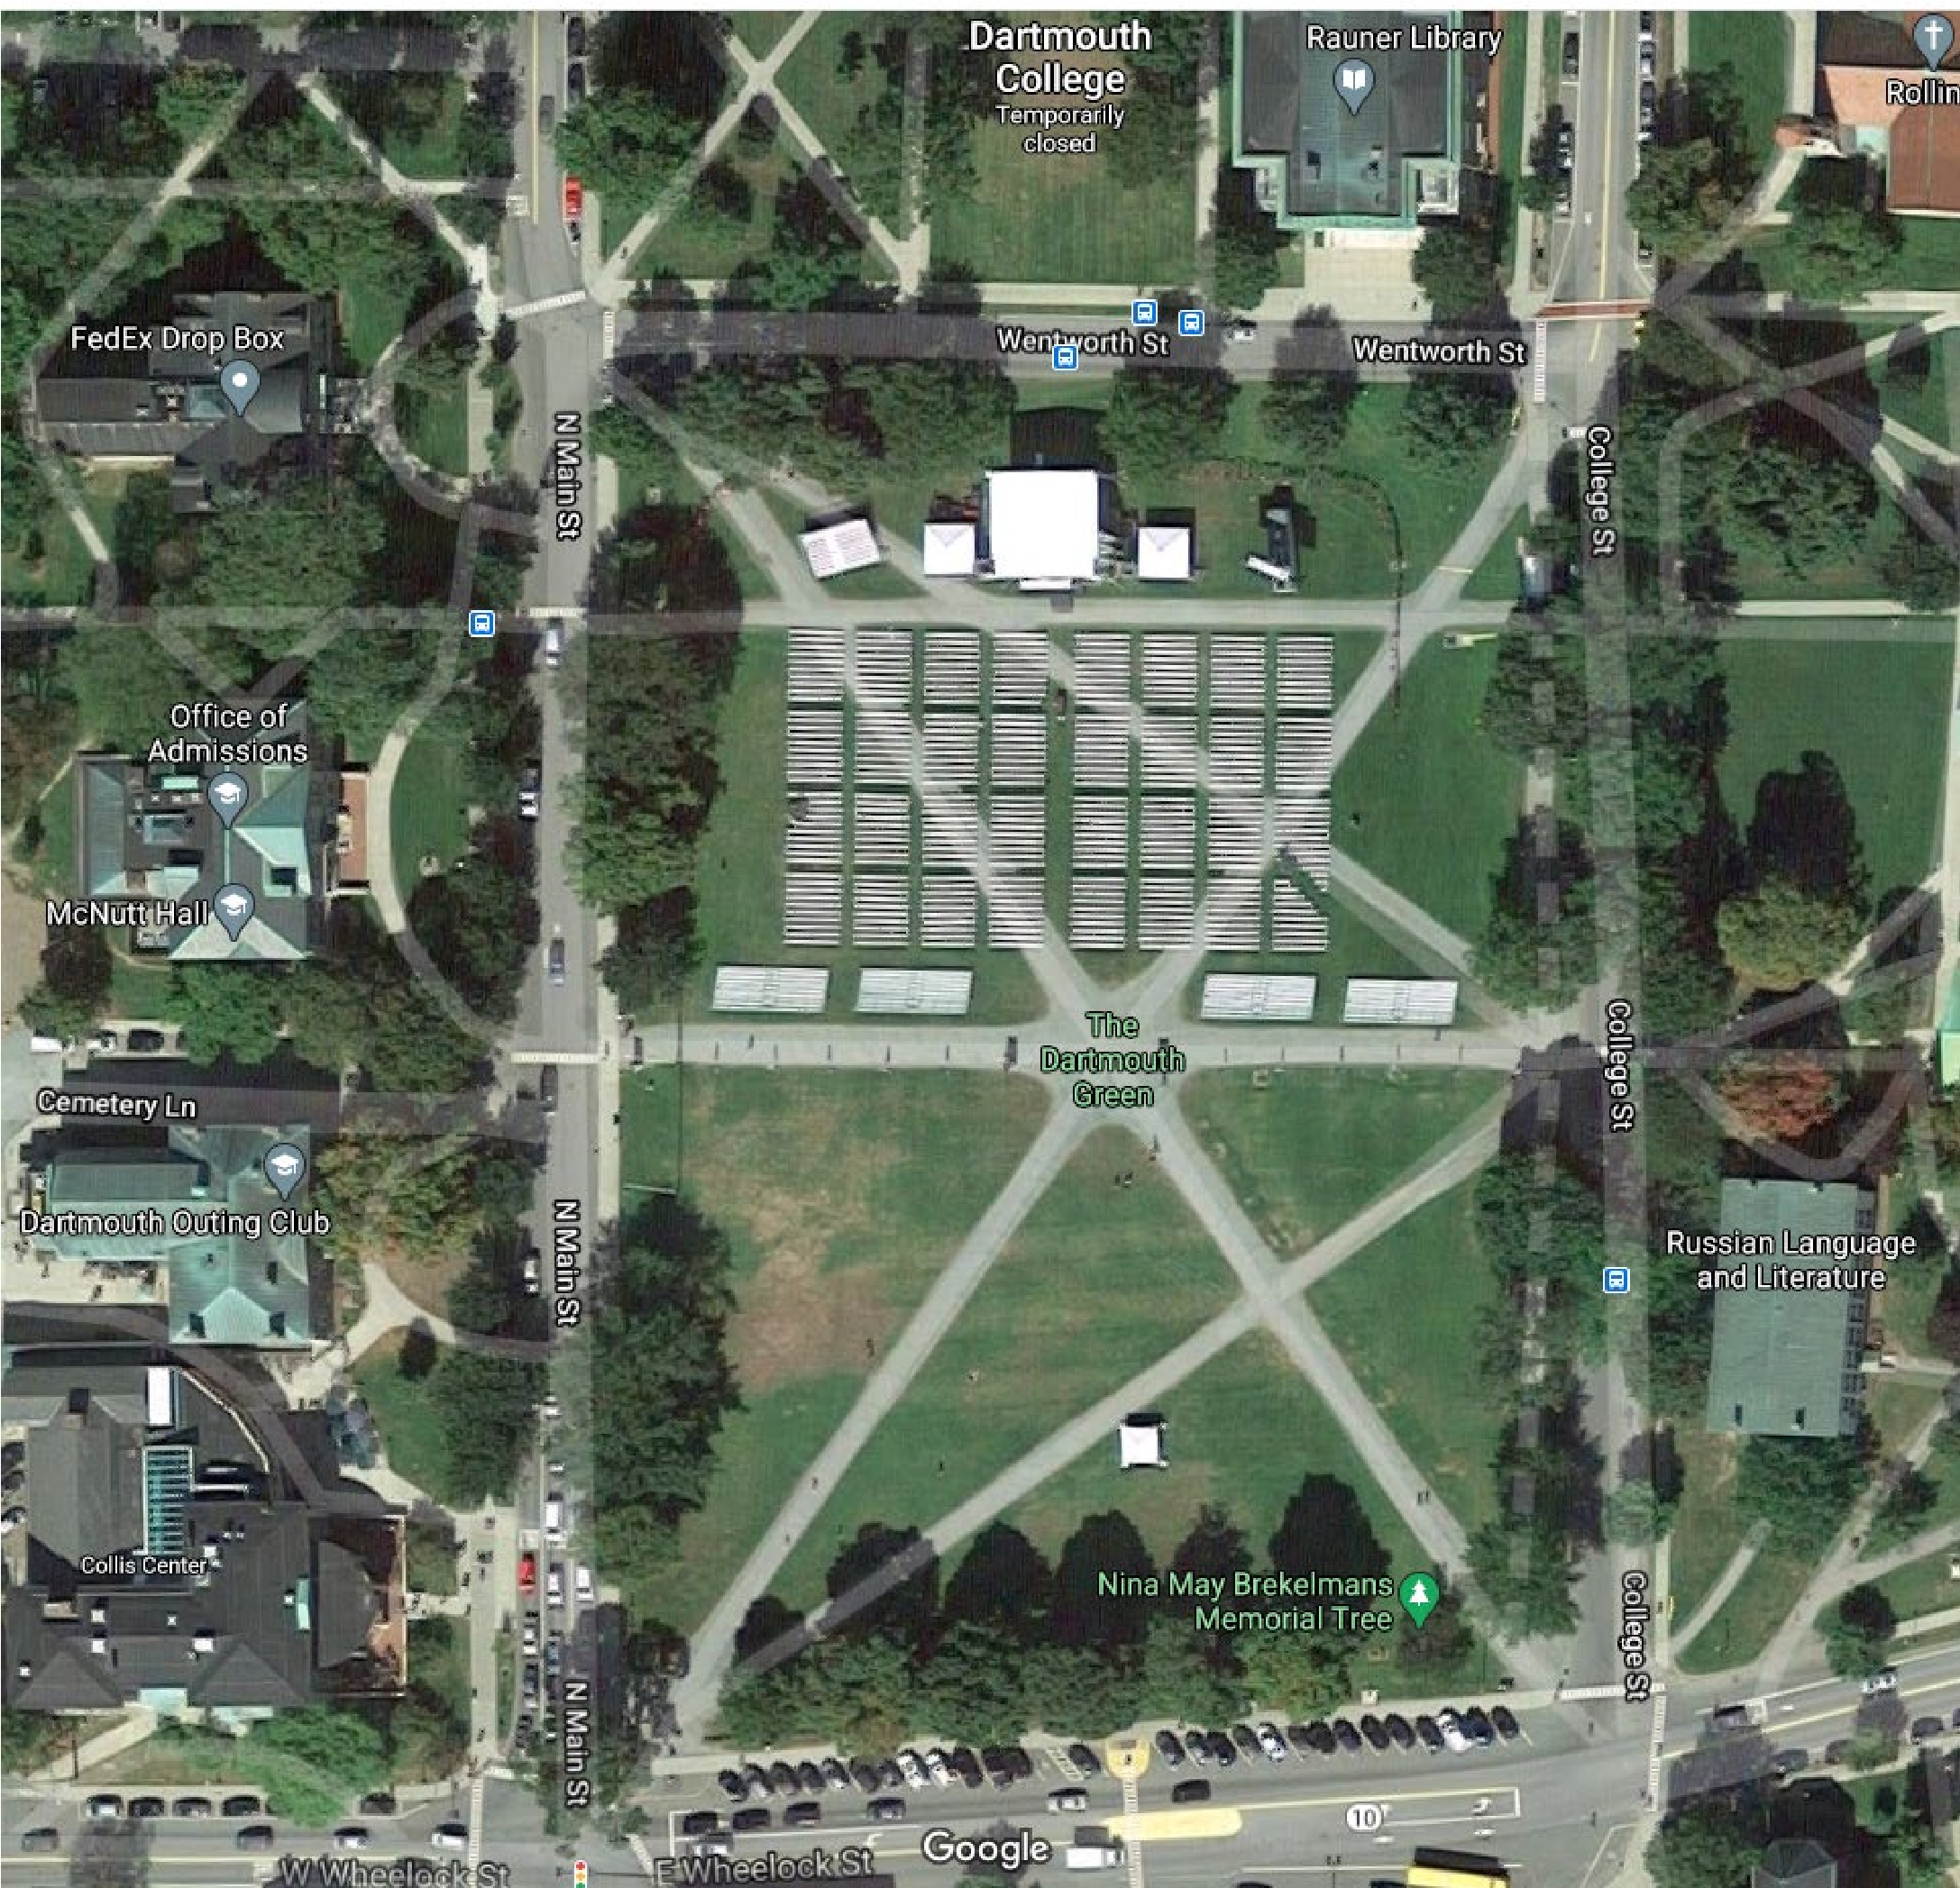
Space 1: W

W
heelock Stre
et
,

2
^{nd}

and
3
^{rd}

spaces
west of

N

Main
Street

Space 2: W Wheelock Street, 4
^{th}
and 5
^{th}
spaces west of N Main Street
Space 3: W Wheelock Street, 6
^{th}
and 7
^{th}
spaces west of N Main Street
Space 4: E Wheelock Street, 1
^{st}
and 2
^{nd}
spaces east of the bus stop
Space 5: College Street, 1
^{st}
and 2
^{nd}
spaces north of Wentworth Street
on the east side of the street
Space 6: N Main Street, 1
^{st}
and 2
^{nd}
spaces north of Wentworth Street
on the east side of the street
**On days when food trucks occupy Space 1, no parking will be
permited in the first parking space on W Wheelock Street
Food Truck Zone 2
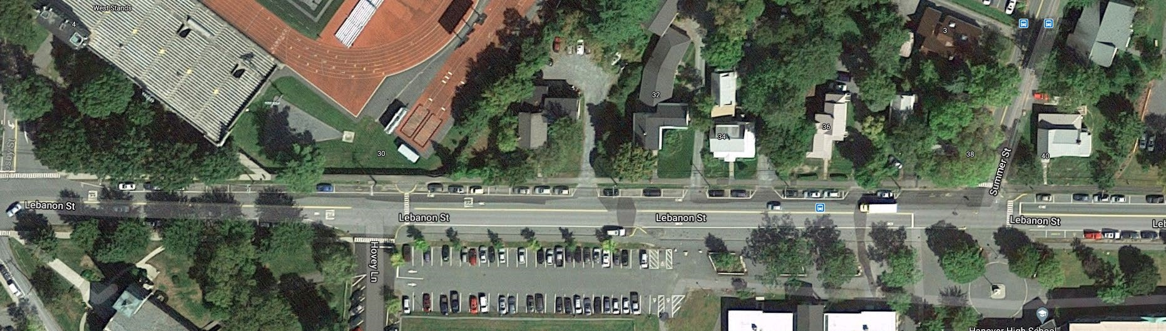
Space
7

:
Lebanon Street
,

1
^{st}

and
2
^{nd}

spaces
north
west of Hovey Lane

on the northeast side of the street
Space 8: Lebanon Street, 1
^{st}
and 2
^{nd}
spaces southeast of Summer
Street
on the
north
east side

of the street

HANOVER, NH
MOBILE FOOD TRUCK
PERMIT PARKING APPLICATION
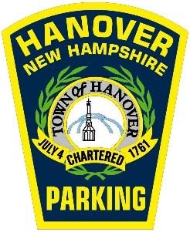
For office use only
Parking Account Number: GN Date of Issue: _____/_____/_____
State Permit on File: Town Permit on File: Picture on File:
PERMITS WILL NOT BE ISSUED WITHOUT THE FOLLOWING INFORMATION
Business Name
:
First Name: ______________________________ Last Name:
Mailing Address:
City: __________________________________________ State: __________ Zip Code:
Telephone: (C)
(H)
(W)
E-Mail Address:
Alternate Contact Person
:
Telephone: (C)

State:
Make:
Model:
Color:
________________________________________
______________________________
Signature
Date
Vehicle Information:
Plate:
Total Vehicle Length (in feet and inches):
E-Mail Address:
___
I have
been provided a copy of the of the Food Truck Guidelines informational sheet and
read all information provided. I understand that Food Truck Space reservations are
first-come, first-served and I
may not always be able to reserve a Food Truck Space. I
further understand that failing to
comply with these
guidelines

may

result in

revocation of this permit
.
Please initial and sign:

