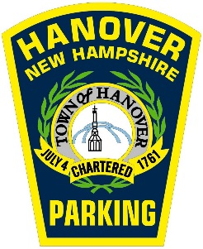
Hovey / Lebanon Parking Permit

Hovey / Lebanon Permits are available for $55.00/MONTH. Permits are invoiced on the 1st of each month after the initial application and issuance at Town Hall. Payments can be made by going to https://parking.hanovernh.org. Permits are invoiced to an account on the first of each month and continue until canceled. If a permit becomes expired due to non-payment of an invoice, there will be a $30.00 administrative fee for re-activation. Permits cannot be renewed if there are outstanding parking tickets on the account. These permits are valid in one of the 120 spaces on Sanborn Road, lower Lebanon Street, and Hovey Lane in the areas highlighted in RED on the map. There are also long-term permit holders parking in this area and the permits are oversold, so there may not always be an available space. Please ensure that your permit is prominently displayed. A 30-day advance cancellation notice is required when terminating a permit to stop the billing process.
- There are all day meters located on the south end of Crosby Street and the east side of Lebanon Street between Crosby Street and Hovey Lane (in the areas highlighted in GREEN on the map). The rates for these meters are cheaper than most downtown meters and up to a full day can be purchased. There are also two (2) two-hour meters in front of the Hanover High School for short term parking in the area. You cannot park in these metered spaces with a Hovey / Lebanon Permit.
- Anyone choosing to park on Town streets should be familiar with all parking rules and regulations, as well as NH state laws. This includes no on-street parking from 12:01 AM -7:00 AM during the winter parking ban, no left wheels to the curb, and no backing into angled parking spaces. A copy of the town parking ordinance can be found at www.hanovernh.org in the “Rules and Regulations” section under the Parking heading.
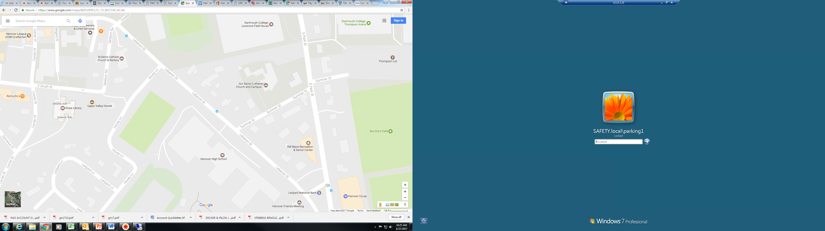
Hovey / Lebanon Permit parking

All day meter parking (10 hour max)

2 hour meter parking

Drop-off / pick up zone
Questions can be directed to the Hanover Parking Division at 640-3220 or email us at parking@hanovernh.org. Our office hours in Town Hall are 8:30 a.m. to 4:30 p.m., Monday - Friday.
HANOVER, NH
HOVEY LANE AND LEBANON STREET
PERMIT PARKING APPLICATION

For office use only

Parking Account Number: GN

Hovey Lebanon Permit Number: Date of Issue: _____/_____/_____

PERMITS WILL NOT BE ISSUED WITHOUT THE FOLLOWING INFORMATION

First Name: ______________________________ Last Name:

Person typically driving the vehicle (if different):

Mailing Address:

City: __________________________________________ State: __________ Zip Code:

Telephone: (C) (H) (W)

E-Mail Address:

Employer:

Two vehicles may be registered to the permit, however only one may be parked in the permitted area at any given time.

Plate: State: Make: Model: Color:

Plate: State: Make: Model: Color:

Please initial and sign:

_____ I have read the attached information and understand that I may not always be able to access a parking space. I further understand that all Town of Hanover Parking Ordinance rules apply and that parking outside of designated parking areas for Hovey / Lebanon Permits or failing to display the permit will result in enforcement action.

________________________________________ ______________________________
Signature Date

