HANOVER, NH
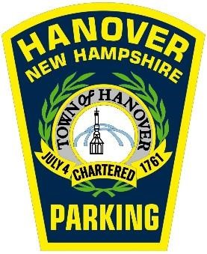
DOWNTOWN EMPLOYEE PARKING PERMIT

APPLICATION

Please read this carefully
Permits will be issued only to central business district employees that meet specific eligibility criteria. Having an active permit will allow you to park in one of the 50 allocated Town of Hanover spaces in the Thompson Arena Lot for free, or in the Hanover Parking Garage for $8.00 after 8:30am. We can allow up to 50 permit holders in the garage daily, depending on public use. There is no cap to the number of permits issued and spaces in these two areas will be available on a first-come-first-served basis so not all permit holders will be accommodated.
A person is eligible for a Downtown Employee Permit if:
- They work in the central business district (some exclusions apply – see below)
AND
- They are parked in Thompson Arena or the parking garage while at work only.
A person is ineligible for a Thompson Arena and/or $8.00 Garage permit if:
- They work for Dartmouth College or the Hanover Inn because these employees are eligible for college issued permits.
- They attend or work at Hanover High School – even if a person works at another job in the central business district after school or on weekends.
- Their employer is located outside the central business district, even if a permit has been issued in the past. The boundaries of the central business district square include East Wheelock Street (north), School Street (west), Dorrance Place (south) and Crosby Street / Sanborn Road (east). People working outside these boundaries are ineligible for permits.
All costs associated with providing parking and transportation for central business district employees are paid from revenue generated by central business district parking activity, which is why these rules are necessary. The intent of providing employee parking in peripheral and lesser used areas is to encourage central business district employees to park away from Hanover’s Main Street core, thus keeping prime parking locations open for downtown customers and visitors.
We require each eligible person to complete the application printed on the back side of this page and come to our office to obtain the permit. Incomplete or illegible applications will not be accepted. Our office is located on the main floor of the Hanover Municipal Building at 41 South Main Street. Permits cannot be mailed. Applicants should be prepared to show identification and provide a current (within the last month) pay stub as proof of employment. Applicants with outstanding ticket balances will not be issued a permit until the tickets have been paid.
Garage access starts at 8:30 am. Questions about Downtown Employee Parking Permits can be directed to the Hanover Parking Division at 603-640-3220 or parking@hanovernh.org. Our office hours are 8:30 a.m. to 4:30 p.m., Monday - Friday.

HANOVER, NH
DOWNTOWN EMPLOYEE PARKING PERMIT

APPLICATION

For office use only  Account Number:  Permit Number: | Date of Issue: _____/_____/_____
Please Print Clearly - Incomplete or illegible applications will not be accepted
