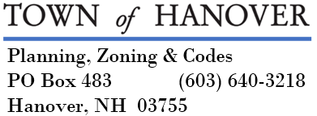

ZONING BOARD OF ADJUSTMENT

AGENDA
July 24, 2025

- Public hearings:

CASE #34064-Z2025-07-9: Wayne Young, property owner of record, is requesting variances from the frontage and lot size requirements of Section 405.8, and from the ‘square box’ requirement of Section 501.3 to create a nonconforming at 16 Ledyard Lane, Tax Map 34, Lot 64 in the SR-2 District.
CASE #1025-Z2025-10: Hanover Conservancy, agent for the Clyde D. Watson Trust, property owner of record, is requesting a variance from Section 507.2 to allow creation of a conservation lot at 55 Three Mile Road, Tax Map 10, Lot 25 in the Rural Residential and Forestry Districts which will leave the remainder lot with less than 50 acres in the Forestry District.

- Approve Minutes of 5/1/2025.

- Other Business

